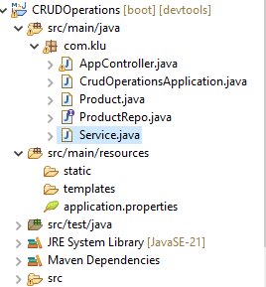

AppController.java

-----------------------------------------

package com.klu;

import org.springframework.beans.factory.annotation.Autowired;

import org.springframework.stereotype.Controller;

import org.springframework.web.bind.annotation.PostMapping;

import org.springframework.web.bind.annotation.RequestBody;

import org.springframework.web.bind.annotation.RestController;

@RestController

public class AppController {

@Autowired

Service s;

//http://localhost:8080/product

@PostMapping("/product")

public String insertProduct(@RequestBody Product product)

{

return s.insertData(product);

}

}

Product.java

import jakarta.persistence.Entity;

import jakarta.persistence.Id;

@Entity

public class Product {

@Id

int id;

String name;

public int getId() {

return id;

}

public void setId(int id) {

this.id = id;

}

public String getName() {

return name;

}

public void setName(String name) {

this.name = name;

}

@Override

public String toString() {

return "Product [id=" + id + ", name=" + name + "]";

}

}

ProductRepo.java

**import** org.springframework.data.jpa.repository.JpaRepository;

**public** **interface** ProductRepo **extends** JpaRepository<Product, Integer>

{

}

Service.java

**import** org.springframework.beans.factory.annotation.Autowired;

@org.springframework.stereotype.Service

**public** **class** Service {

@Autowired

ProductRepo repo1;

**public** String insertData(Product product) {

repo1.save(product);

**return** "Insertes Successfully";

}

}

Application.properties.java

spring.application.name=CRUDOperations

#MYSQL CONFIGURATION

spring.datasource.driver-class-name=com.mysql.cj.jdbc.Driver

spring.datasource.url=jdbc:mysql://localhost:3306/fsad

spring.datasource.username=root

spring.datasource.password=root

#JPA HIBERNATE CONFIGURATION

spring.jpa.hibernate.ddl-auto=update

spring.jpa.properties.hibernate.dileact=org.hibernate.dialect.MYSQLDileact

spring.jpa.show-sql=true

